**Parking Share App**

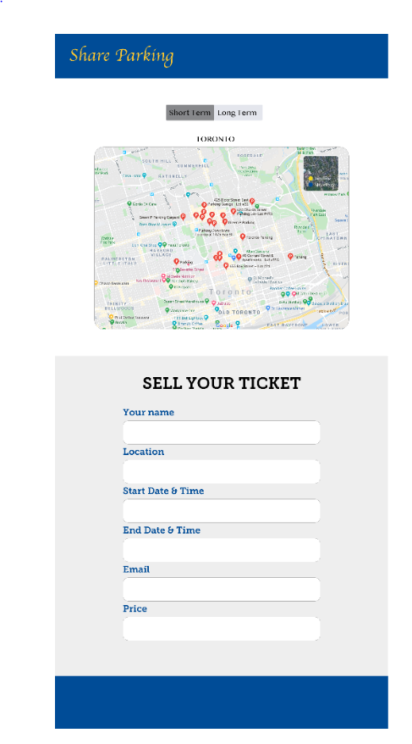

**MVP (minimul viable product)**

* Pre load the database with mock data
* Search for available parking spots
  + Search critieria:
    - location coordinates
    - date / time
    - parking type
* Data will be displayed to user using leaflet map visualization:
  + light (day)
  + dark (night)
  + street view
  + satelite view
* Use tool tip to display additonal info
  + price
  + expiration day

**Extra (if time permits):**

* Sell your unused parking spot
* Data inputs
  + User Info
    - first name
    - last name
    - email
  + Parking Info
    - location (use google API to convert address to lat/lng)
    - price
    - end date
    - end time
* User registration / User login
* Ability to sell a parking spot using a recurring schedule
* Ability to search for time ranges

**Mock Data (CSV file) loaded to SQLite**

* Id
* Lat
* Lng
* start_date
* start_time
* end_date
* end_time
* duration_type (short term / long term) [optional - derived field based on rules]
* price
* email
* phone
* parking_type (private / public / indoor / outdoor)

**Architecture Diagram**

